**PlastiScan: HDPE and PET Plastics Bottles Detection**

**Contents**

Project Description: 1

Technical Architecture: 2

Pre-requisites: 2

Project Flow: 2

Milestone 1: Create. ipynb Notebook 2

Activity 1: Import the required libraries 3

Activity 2: Collection of custom data for HDPE and PET Plastics Bottles Detection: 3

Activity 3: Sample Data Visualization 3

Activity 4: Load pre-trained model with YOLO 5

Activity 5: Training 6

Activity 6: Detected Image after Applying Yolov8c 7

Milestone 2: Application Building 7

Activity1: Building Html Pages: 8

Activity 2: Build Python code: 9

Activity 3: Run the application 11

Activity 4: Prediction 11

## Project Description:

PlastiScan is an innovative solution aimed at accurately identifying HDPE and PET plastic bottles, empowering efficient recycling processes. By leveraging advanced technology, it optimizes recycling workflows, contributing to environmental sustainability.

## Technical Architecture:

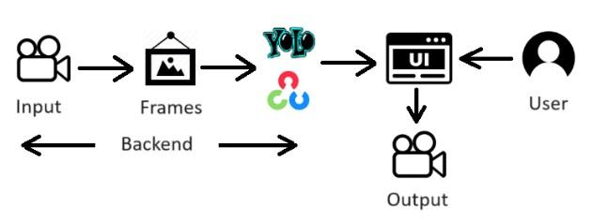

### Pre-requisites:

1. Spyder, Jupyter notebook
2. Yolov9, Flask

### Project Flow:

* The user interacts with the UI to enter the input.
* Entered input is analysed by the model which is integrated.
* Once the model analyses the input the summary is showcased on the UI

To accomplish this, we have to complete all the activities listed below,

Create .ipynb Notebook

* Import the required libraries
* Collection of custom data for fruit detection
* Sample Data Visualization
* Load pre-trained model with OpenCV
* Training
* Detected Image after Applying Yolov9c

Application building

* Building HTML page
* Build Python code
* Run the application

## Milestone 1: Create .ipynb Notebook

We will create .ipynb notebook to train the yolov9 model (pre-trained model) on our custom dataset

### Activity 1: Import the required libraries

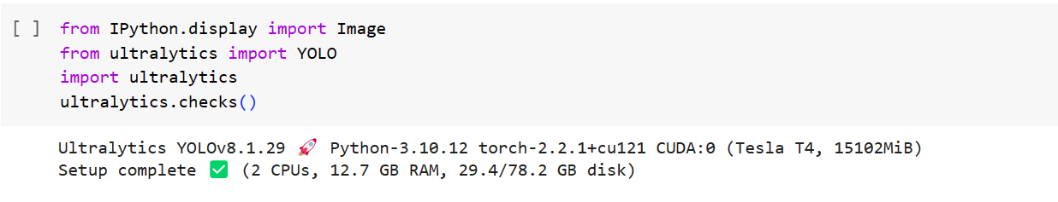

### Activity 2: Collection of custom data for HDPE and PET Plastics Bottles Detection:

[**Dataset**](https://universe.roboflow.com/fruitdetection-sboxl/fruit-n1rgn)- [HDPE and PET Bottle Plastic Waste (kaggle.com)](https://www.kaggle.com/datasets/mariaqib/hdpe-and-pet-bottle-plastic-waste)

The dataset comprises three folders: train, test, and valid, with 5858, 734, and 732 image-annotation pairs respectively. Images are stored in JPG format, each accompanied by an XML file containing object annotations. The train set is for model training, test for evaluation, and valid for parameter fine-tuning and generalization assessment. Annotations typically include class labels and bounding box coordinates for objects like plastic bottles. This structured setup simplifies data loading and preprocessing, facilitating efficient object detection model development. The dataset aids in training models for accurate plastic bottle detection, crucial for waste management and recycling initiatives.

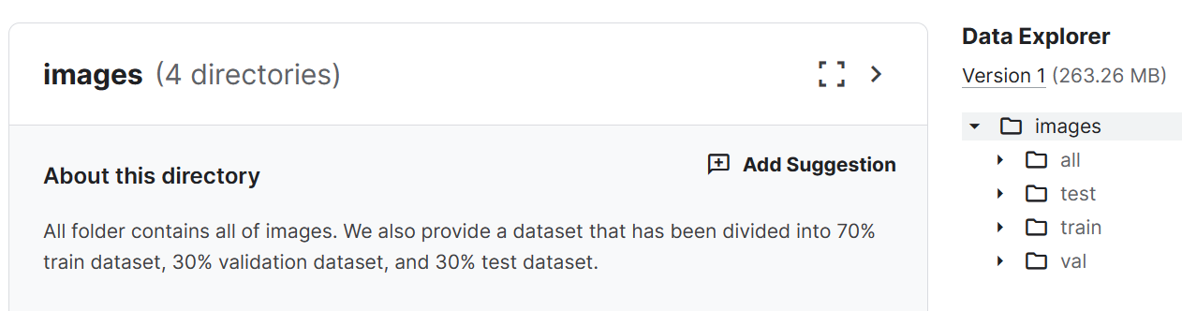

### Activity 3: Sample Data Visualization

There are three classes for this project

1. HDPE class (High-Density Polyethylene)

2. PET class (Polyethylene Terephthalate)

3. caps class

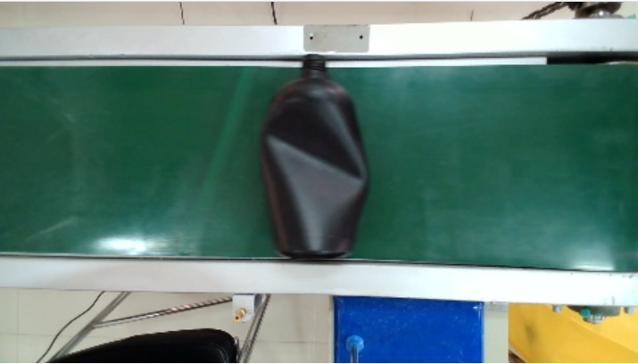 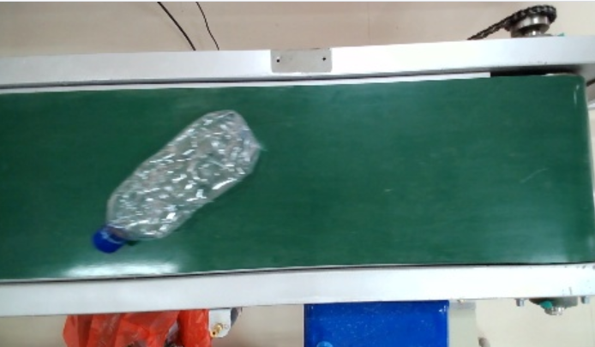

These are the types of bottle and images we have in our dataset. Here the datasets are in .xml format but for YOLO projects the dataset should be in .txt format.

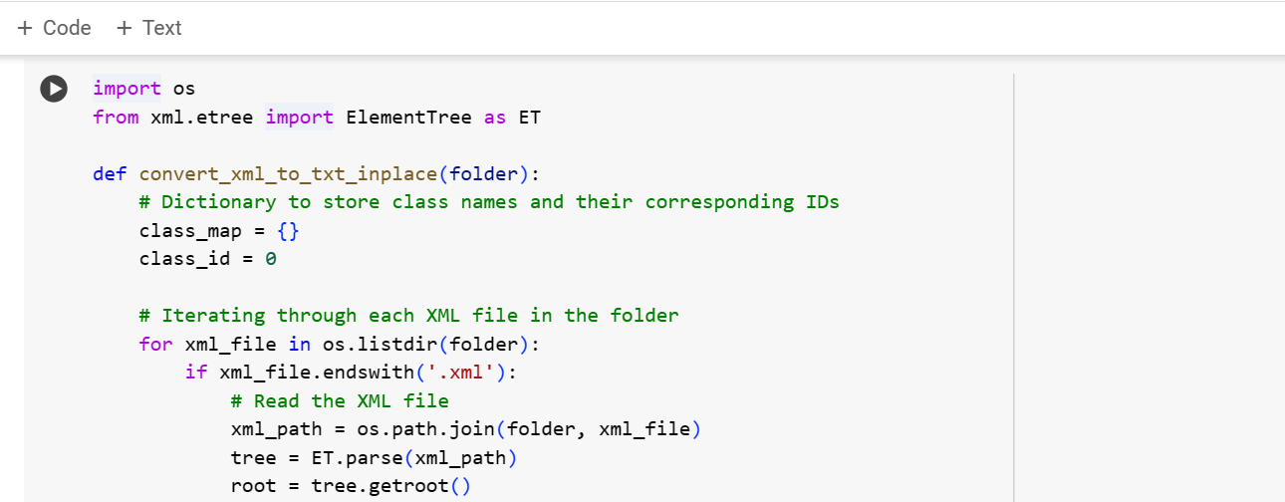

This Python code defines a function `convert_xml_to_txt_inplace.

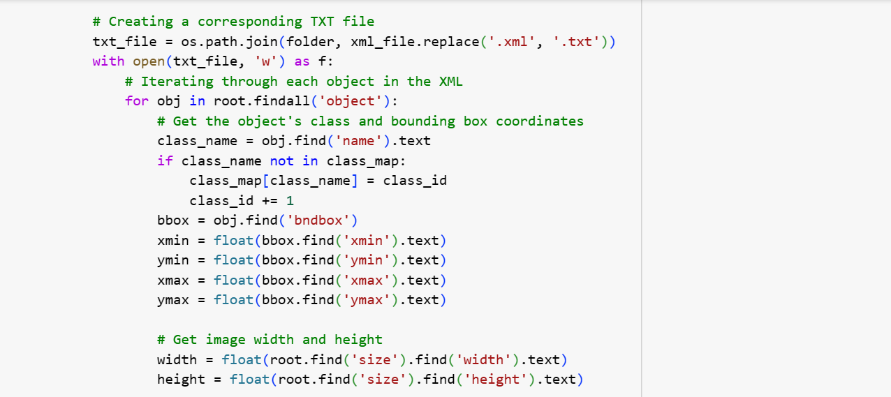

It iterates through each object in the XML file, extracts the object's class name and bounding box coordinates, and checks if the class name is already present in the class map dictionary. If not, it adds the class name to the dictionary along with its corresponding ID, incrementing the class ID. Then, it calculates the normalized coordinates of the bounding box based on the image width and height obtained from the XML file.

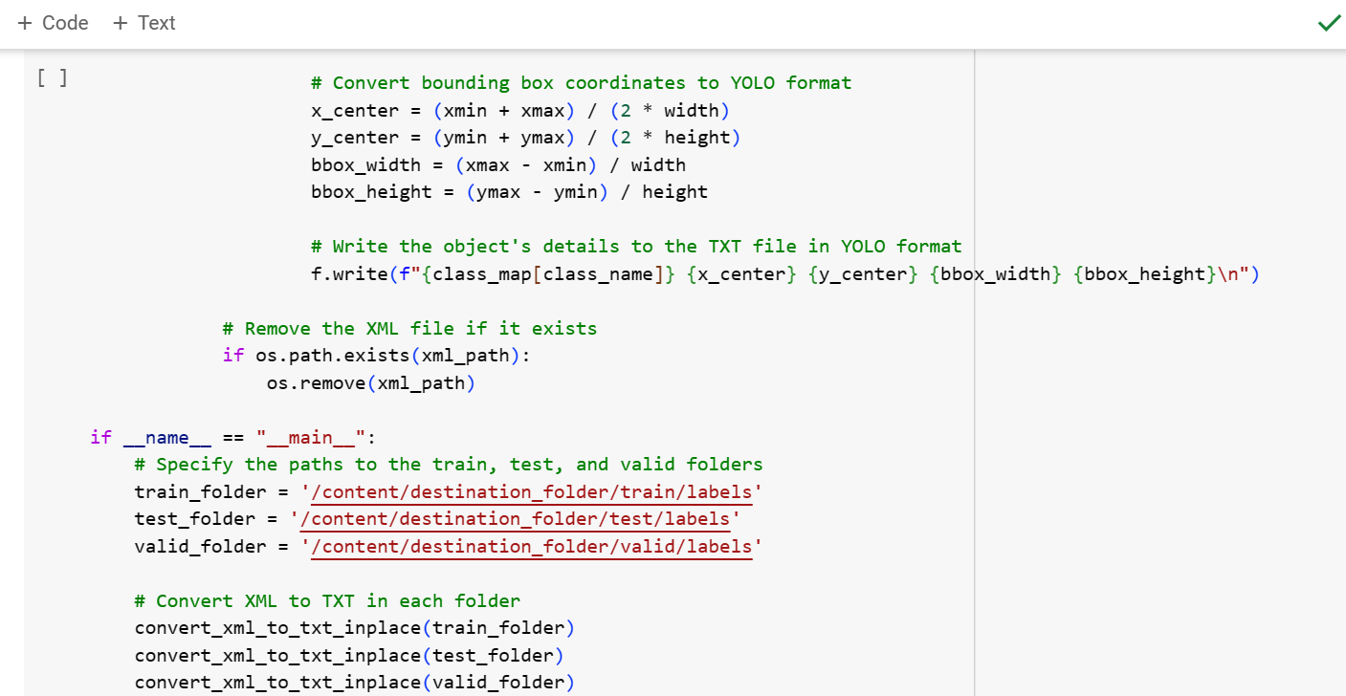

The bounding box here calculates the center coordinates of the bounding box (`x_center`, `y_center`), as well as the normalized width and height of the bounding box (`bbox_width`, `bbox_height`) relative to the image dimensions.

Finally, the script is set up to convert XML to TXT in specified train, test, and validation folders, executing the conversion for each folder separately.

Now, the dataset is in a proper format to be used for YOLOv9 project.

### Activity 4: Load pre-trained model with YOLO

We have different YOLOv9 model like yolov9c.pt and yolov9e.pt.

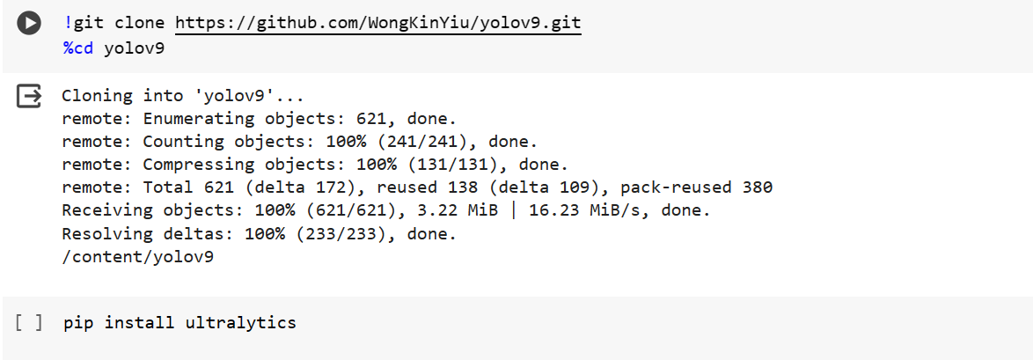

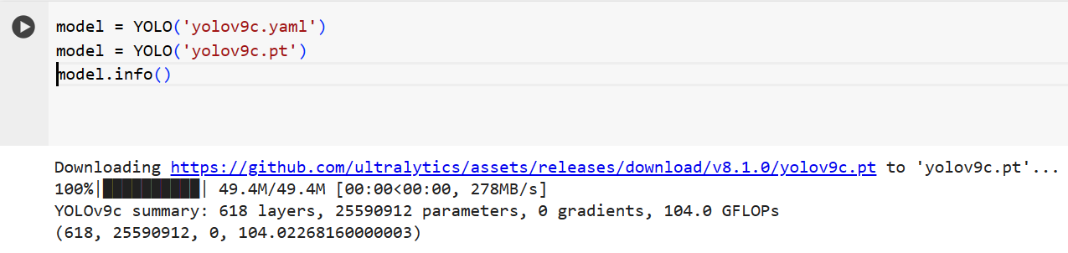

The yolo model is being downloaded from the original site.

model = YOLO('yolov9c.yaml') Load pre-trained model weights (directly usable for detection).

model = YOLO('yolov9c.yaml') Load model configuration (architecture details) and potentially weight loading instructions.

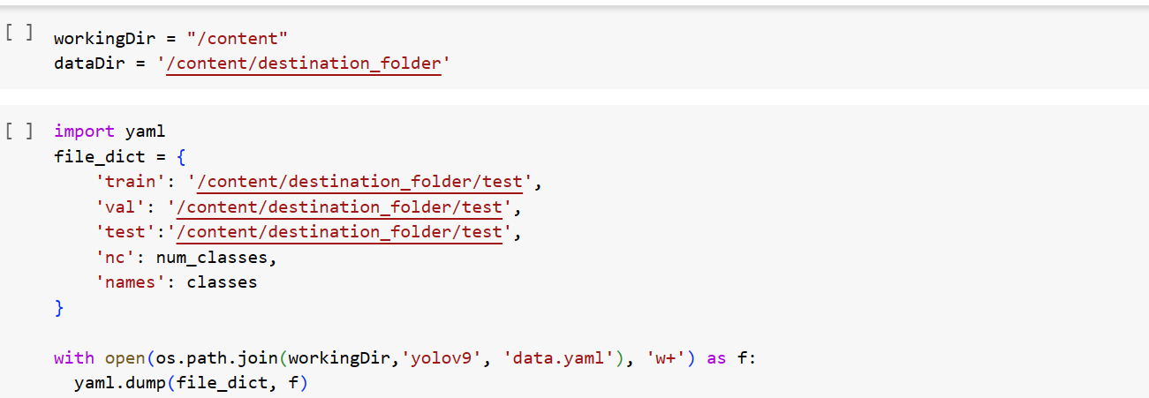

Here, like YOLOv8 there is a need to make .yaml file and give the path for the train, test and valid dataset.

### Activity 5: Training

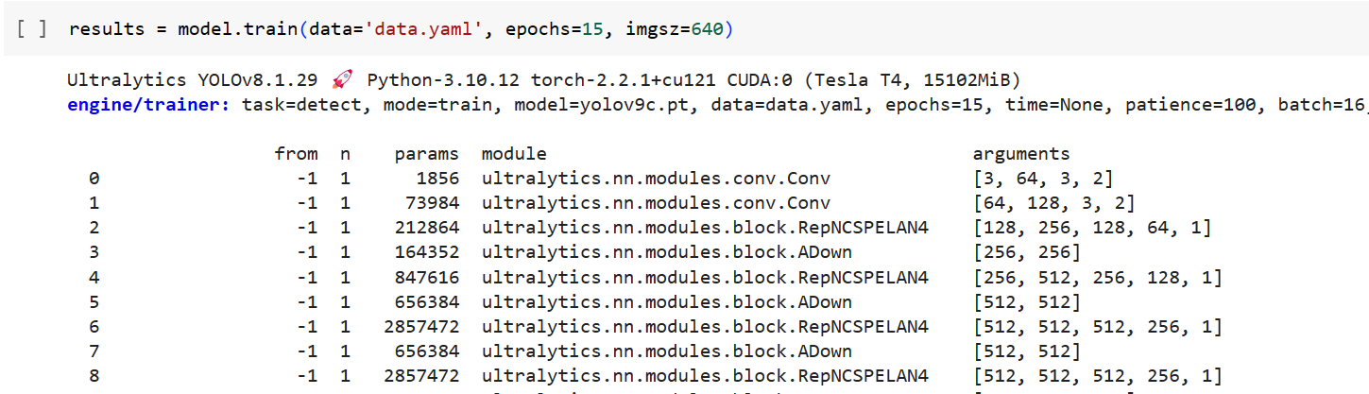

The model is being trained on data.yaml file for detection.

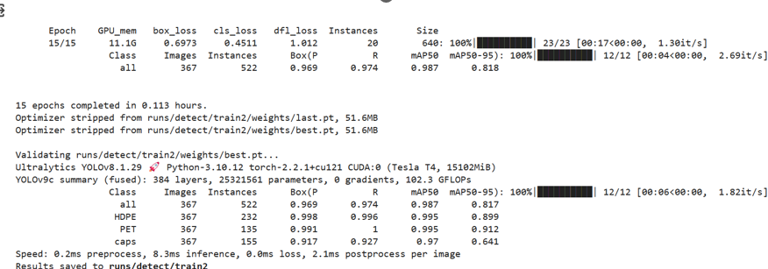

### Activity 6: Detected Image after Applying Yolov8c



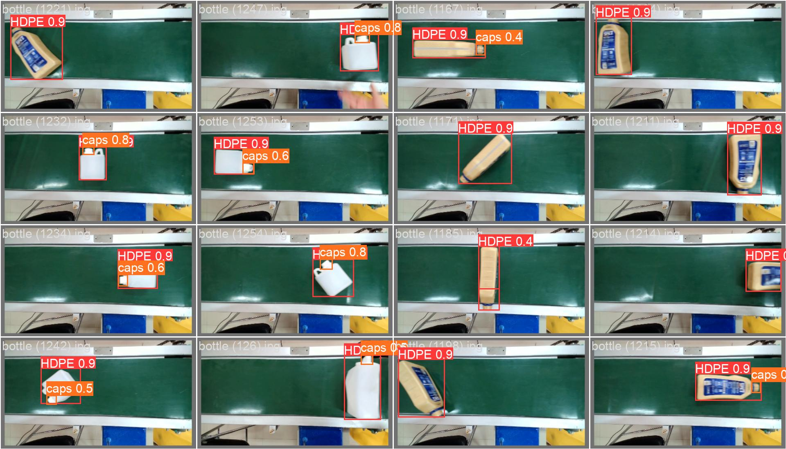

After this download the best.pt file for further prediction of test data.

## Milestone 2: Application Building

This section has the following tasks

* Building HTML Pages
* Building server-side script

### Activity1: Building Html Pages:

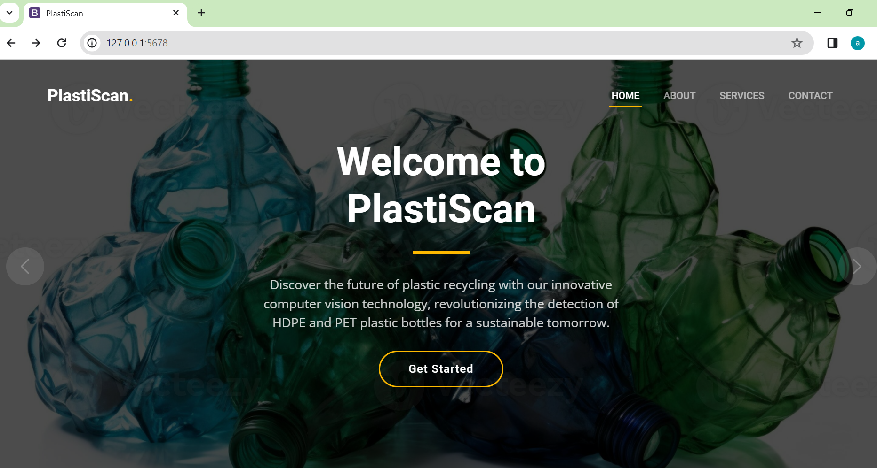

When ABOUT is being clicked, the below page will be shown:

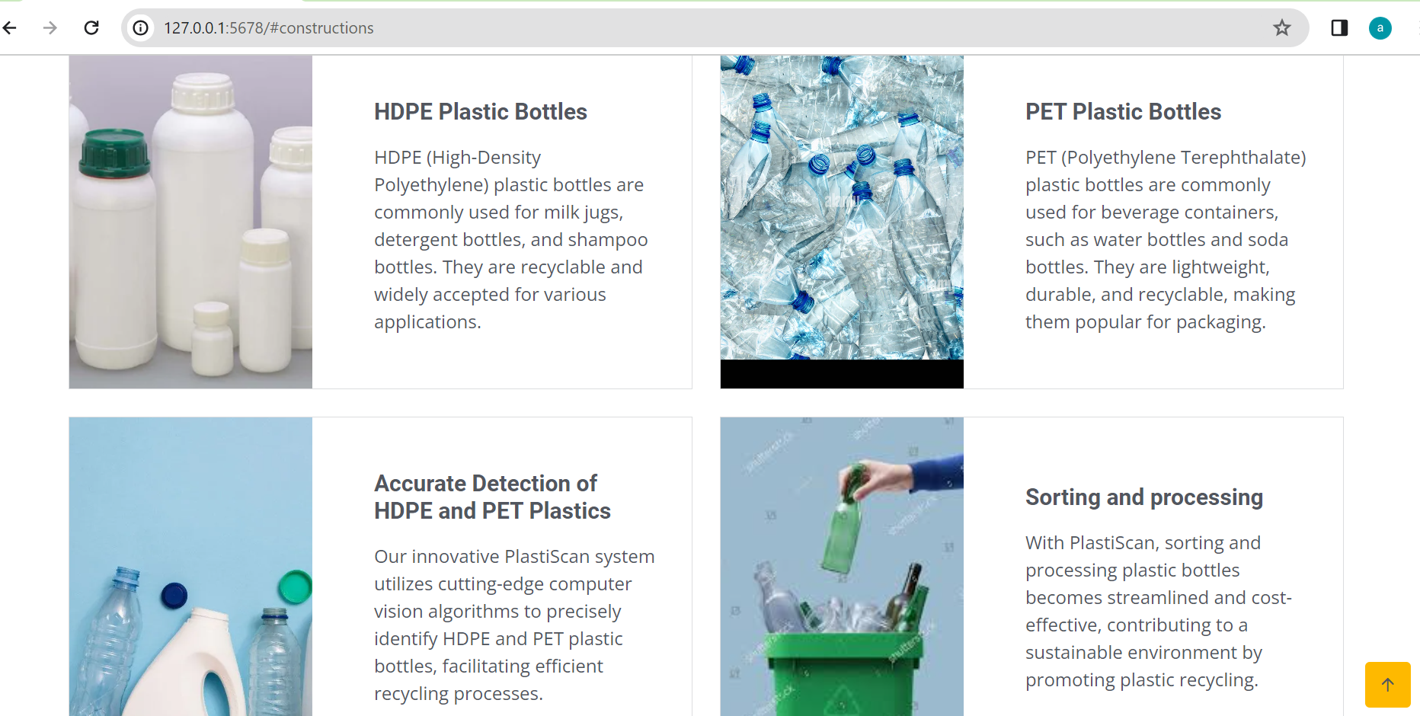

When SERVICES is being clicked, the below page will be shown:

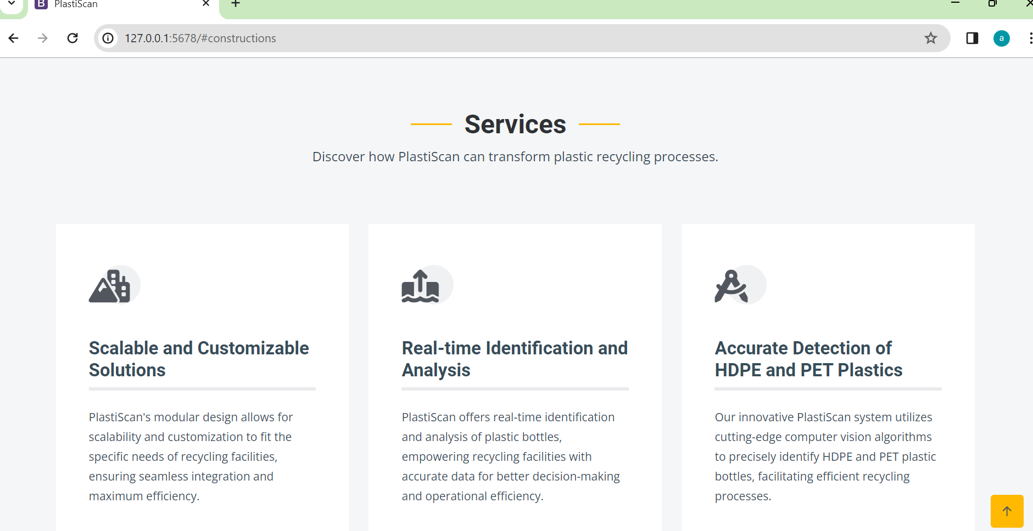

When CONTACT is being clicked, the below page will be shown:

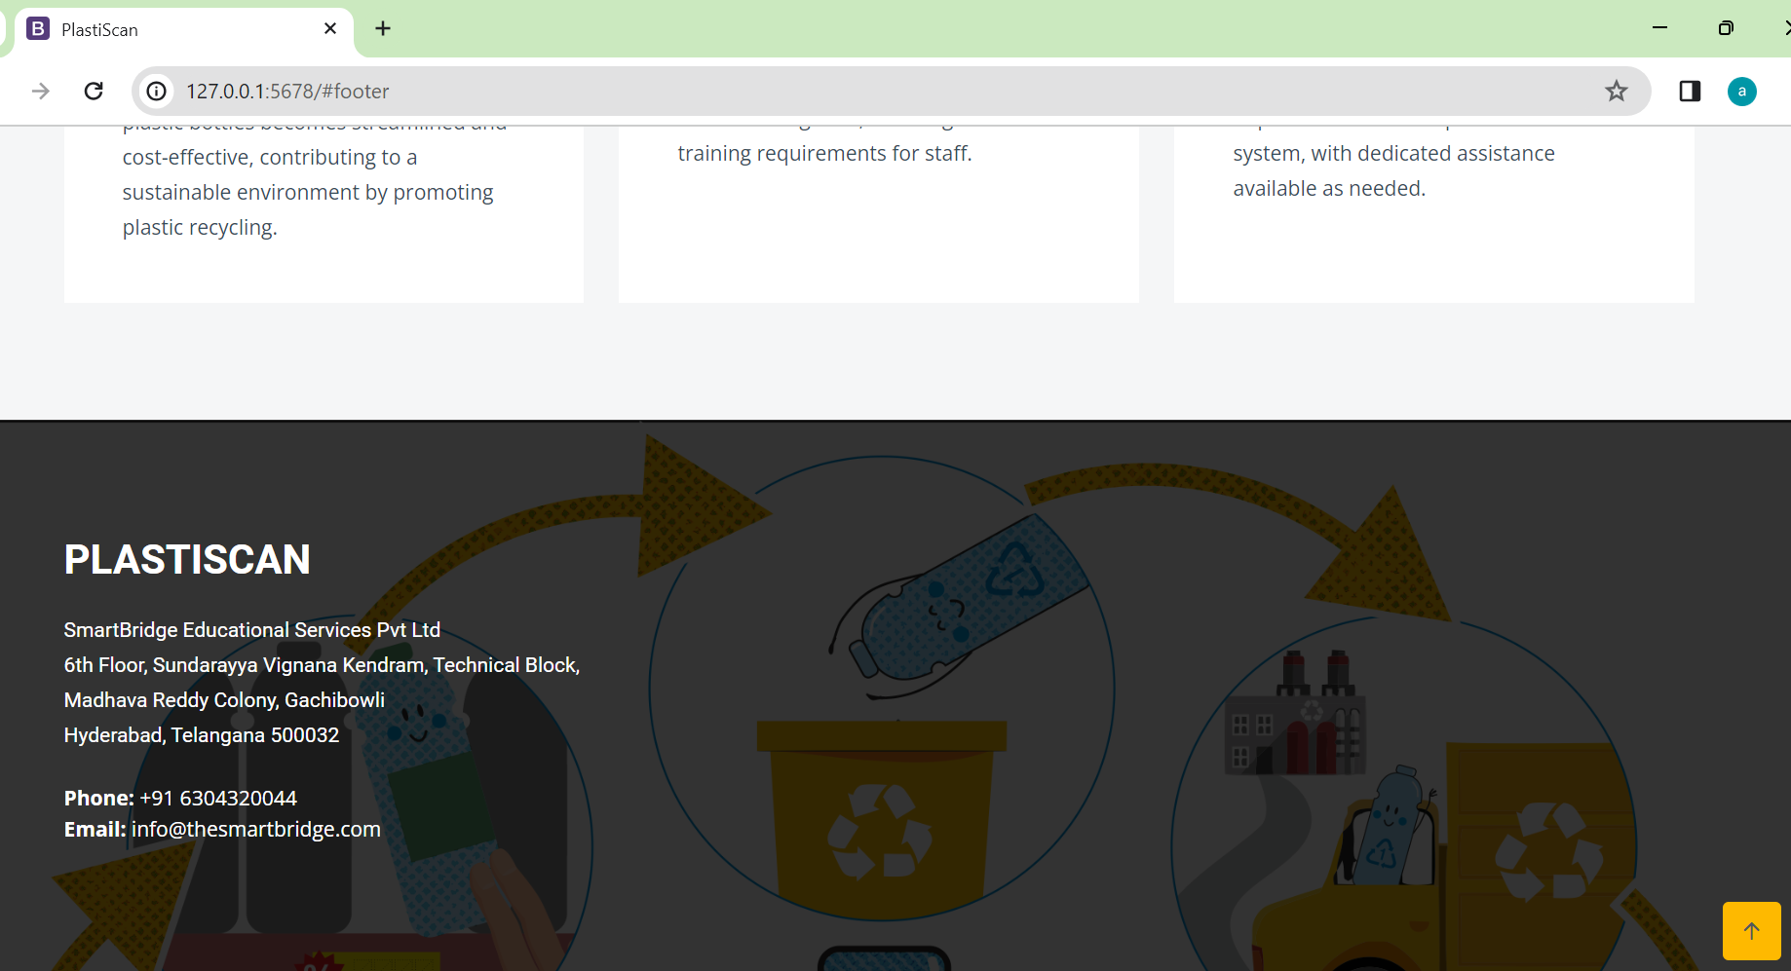

### Activity 2: Build Python code:

Import the libraries

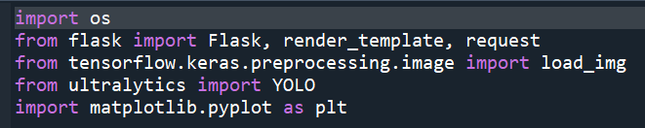

Importing the Flask module into the project is mandatory. An object of the Flask class is our WSGI application. The Flask constructor takes the name of the current module (__name__) as an argument.

Load Pretrained yolov9c model which trained on our custom dataset.

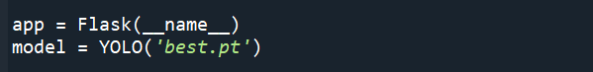

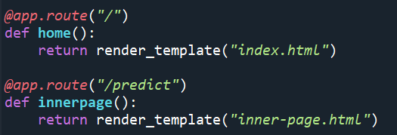

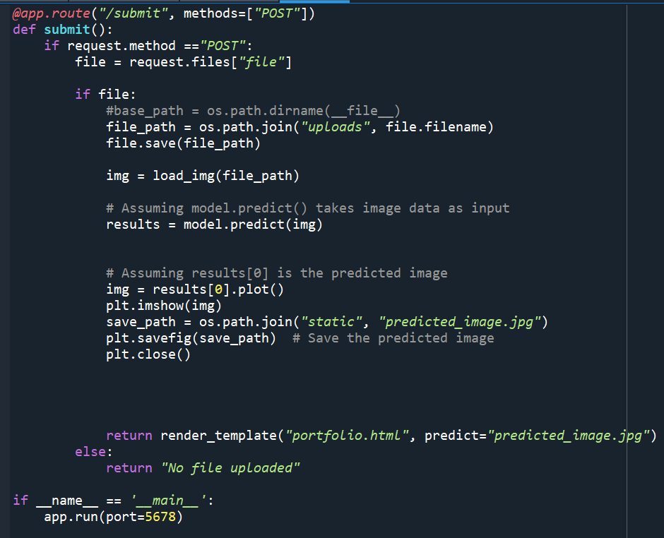

This Python code defines a Flask route `/submit` that accepts POST requests. When a file is submitted via a form, it saves the file to a specified directory (`uploads`), loads the image, and passes it to a machine learning model for prediction.

The predicted image is then plotted, saved as `predicted_image.jpg`, and rendered in a portfolio HTML template.

Finally, the Flask app runs on port 5678. This code essentially serves as a simple web application for image prediction using Flask and a machine learning model.

### Activity 3: Run the application

* Open the anaconda prompt from the start menu
* Navigate to the folder where your Python script is.
* Now type the “app.py” command
* Navigate to the localhost where you can view your web page.
* Click on the Inspect button from the top right corner, and see the result/prediction on the web, Copying the file path to get the ‘http://127.0.0.1:5678/’.

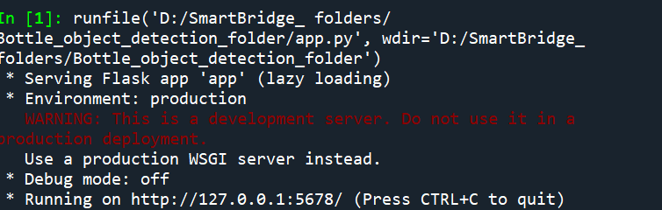

### Activity 4: Prediction

**Test1:** We can see the result of bottle detection by uploading the image below. Here, the file is being uploaded in inner-page.html which will give the prediction in next page(portfolio.html).

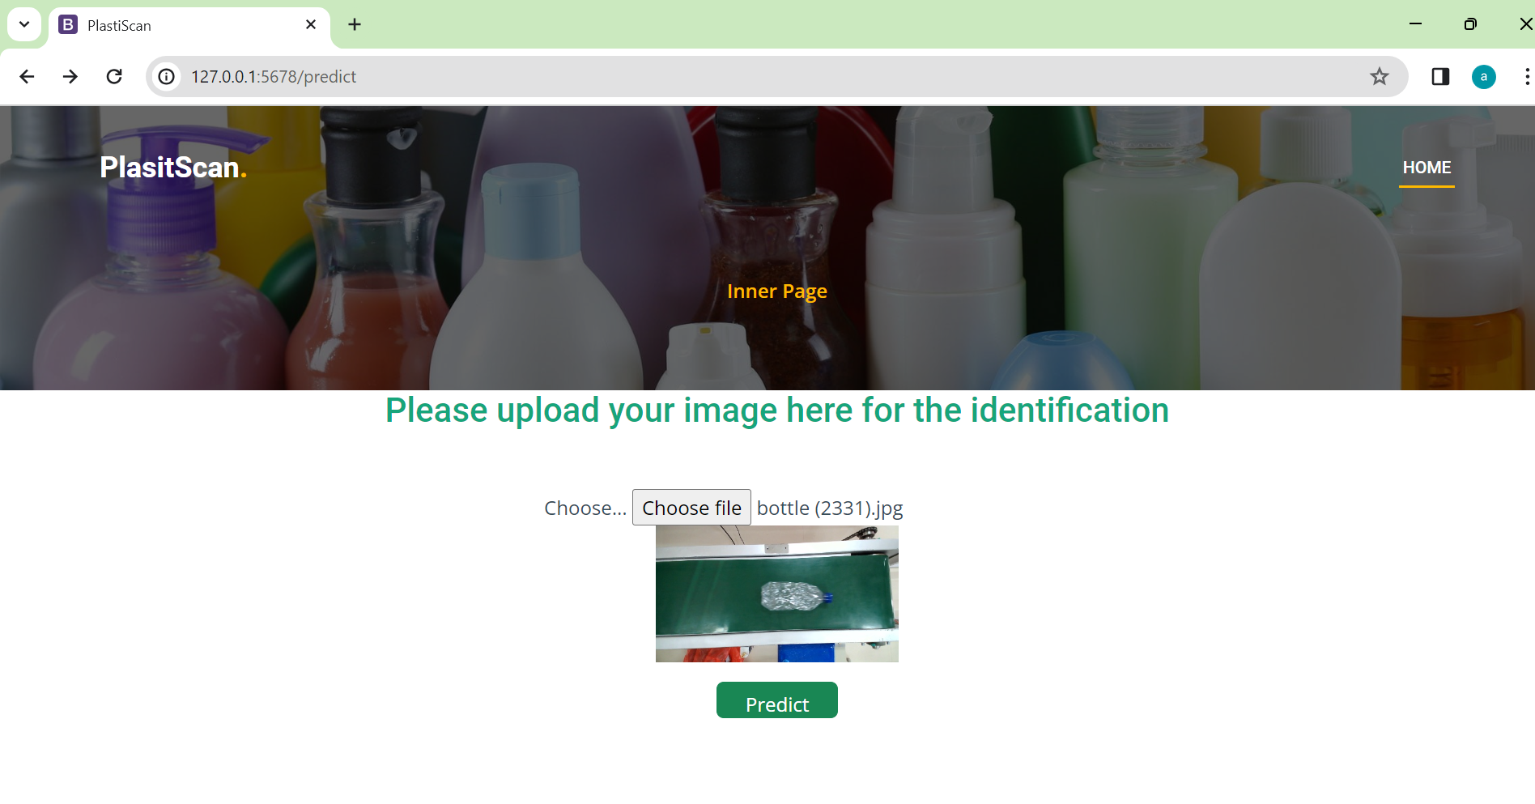

**Output1:**

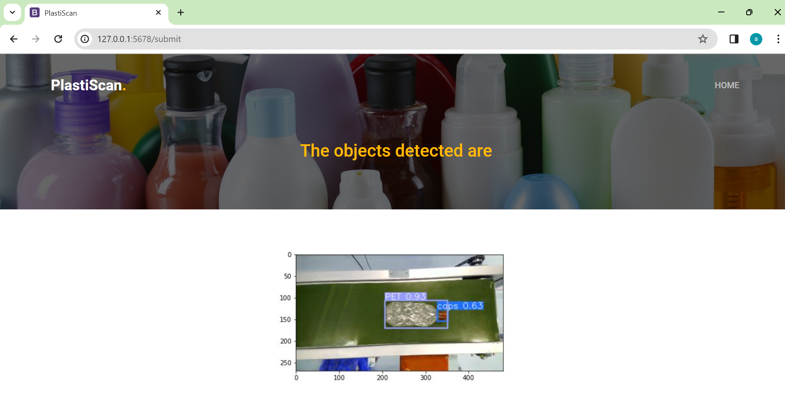

Now, the bottle of PET material and Caps are being detected with confidence score of 0.93 and 0.63 respectively.

**Test 2:**

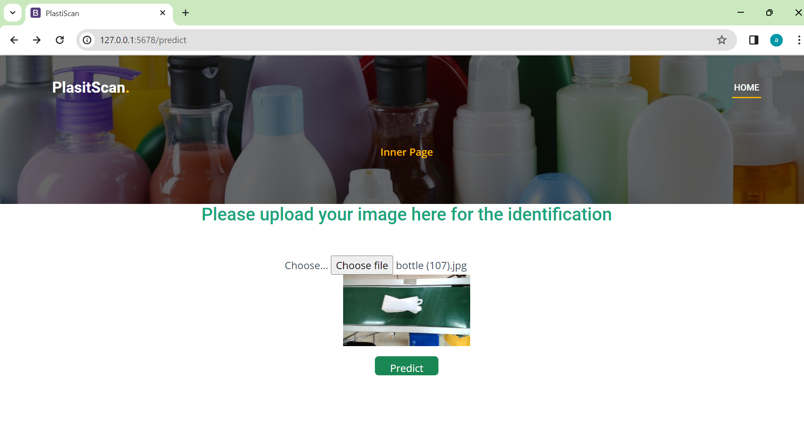

**Output 2:**

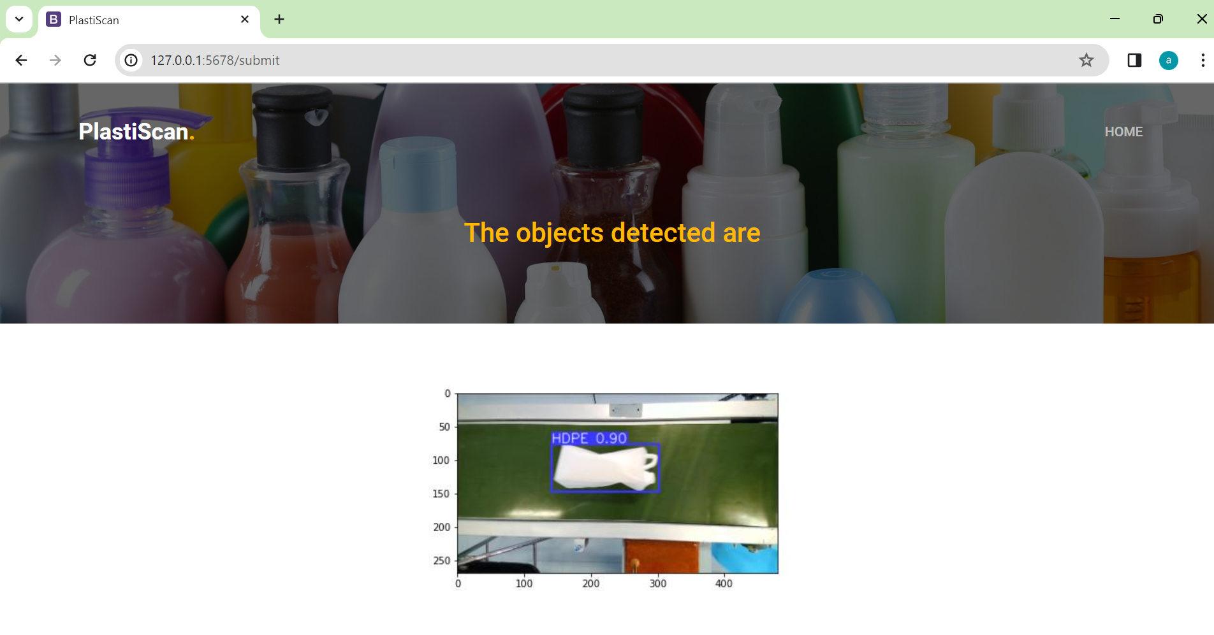

The bottle is getting predicted as HDPE material with confidence score of 0.90.